Activity 1.1: Systems and Scale Unit Pretest
1. When a log burns, there is heat and light energy in the flame. Where does the heat and light energy come from? Select True or False for the following statements.
Some heat and light energy:
T F comes from the air
T F is created by the flame
T F comes from the log
T F comes from the person who lit the log

Which ONE of the following do you think provides the MOST energy to the flame?
a. Energy stored in the air
b. Energy created by the flame
c. Energy stored in the log
d. Energy from the person who started the fire

Explain your choices. Where does the heat and light energy in the flame come from?

2. After a log burns for a while, it weighs less than it originally did before it was burned. What happened to some of the matter that used to be in the log? Select True or False for the following statements.
Some matter from the log was converted into
T F ashes
T F carbon dioxide
T F heat and light energy
T F water vapor

Which ONE of the following do you think MOST of the matter in the burning log was converted into?
a. Ashes
b. Carbon dioxide
c. Heat and light energy
d. Water vapor

Explain your choices. What happened to the matter in a log as it burned?

3. A scientist has discovered a new living organism: the glubex. He put a glubex on the scale, weighed it, and then returned it to its habitat for one day. The next day he weighed it again. Here is what he found:
Original mass of the glubex: 1.52 grams
Mass of the glubex after one day: 1.64 grams
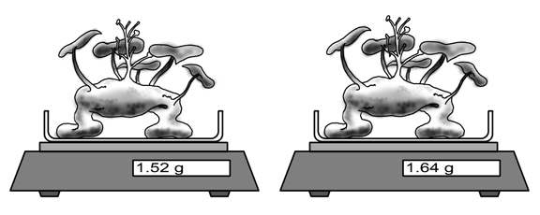
Decide if you agree or disagree with each of the students below.

A student, Patrick, claims: “The chemical energy stored in the glubex’s fat was used to make new atoms. These new atoms caused the increase in the mass of the glubex.”
Circle one: AGREE DISAGREE

Another student, Joaquin, claims: The increase in the mass came from the movement of atoms from outside the glubex to inside the glubex.”
Circle one: AGREE DISAGREE

Another student, Devin, claims: The glubex didn’t have to take in atoms or make new atoms in order to grow. Instead the glubex grew because its cells grew and divided.
Circle one: AGREE DISAGREE
Explain your reasoning for your choices.

Choose ONE claim for which you agree with from above. Explain how this claim could be further tested to offer evidence that better supports the claim.

4. A scientist started sorting materials into two groups. Here are the first materials that she put into each group:
Group A: Gasoline, alcohol, wood | Group B: Sand, water, steel, carbon dioxide
a. How would the scientist sort the following materials?
Salt | Group A | Group B
Sugar | Group A | Group B
Pork | Group A | Group B
Soil minerals that help plants grow | Group A | Group B
Leaves from a living tree | Group A | Group B

b. Explain how you decided. How are the materials in Group A different from the materials in Group B?

5. Answer these true-false questions:
True False Carbon is a kind of atom.
True False Carbon is a kind of molecule.
True False There is carbon in pure air.
True False There is carbon in pure water.
True False There is carbon in alcohol.
True False There is carbon in wood.
True False There is carbon in our muscles.

