Carbon TIME FAQ: Which Units Should I Teach?
Note: If which units to teach is determined outside of your classroom, then the information in this document may still be helpful to you, particularly questions about why some units are taught before others, and the difference between the different units.

This document was written for Carbon TIME teachers who are deciding which units to teach, and in which order to teach them. It may also inform curricular teams, departments, and district-level decision-makers. These answers to Frequently Asked Questions explain the logic behind the scope and sequence across Carbon TIME units. For information about elements and sequences of lessons and activities within a unit, see the related “Carbon TIME Instructional Model” document.

Table of Contents
1. How many units are there? .............................................................................................................................. 2
2. How do the three categories differ? ............................................................................................................... 2
3. Does it matter in which order I teach the units? ....................................................................................... 3
4. Why do you recommend teaching Systems & Scale first? ........................................................................... 3
5. I don’t see how Systems & Scale is related to Biology/Life Science. Do I still have to teach it?... 3
6. What is the most typical/common order to teach the units? ............................................................. 4
7. Can I start with the Ecosystems or Human Energy Systems unit? ................................................................ 4
8. I teach 6th grade. We teach ecology. Our district doesn’t address physical sciences until 7th grade. Should I still teach Systems & Scale? .................................................................................................. 5
9. My students studied Systems & Scale last year. Should I skip it this year? ........................................ 5
- I teach a [certain grade/course]. What is your recommended path for my particular course?...... 5
- I am a middle school teacher. Which part of the units should I omit if I want to reduce time and not delve too deeply into what is more typically taught in high school? ....................................... 6
- I don’t have time to teach the entire [fill in the blank] unit. Which parts should I prioritize, and which parts may I omit? .................................................................................................................................. 6
- I am teaching multiple units. Some content is repetitive. What should I prioritize/omit? ..... 6 14. Can I teach Carbon TIME to elementary school students? ................................................................. 7
15. How does Carbon TIME build deep and connected knowledge and practice around big ideas?.. 7

- How many units are there?
A: There are a total of 6 Carbon TIME units. The units are divided into 3 categories:

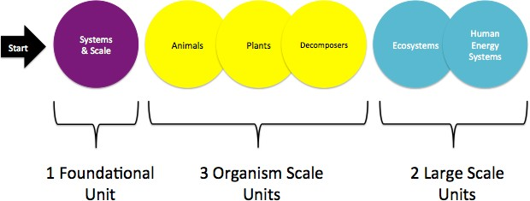

How do the three categories differ?
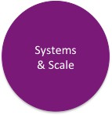
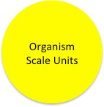
The Foundational unit (Systems & Scale) is taught first in every Carbon TIME unit sequence, no matter which other units you are teaching. It can also be revisited in following years if students are struggling with basic principles of matter and energy. In this unit, students trace matter and energy through a flame when ethanol burns, building foundational concepts and practices. The Carbon-transforming process addressed in this unit is combustion.

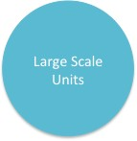
The Organism Scale units (Animals, Plants, and Decomposers) engage students in tracing matter and energy through organisms (e.g., mealworms, lettuce plants, and bread mold). These units address the same big ideas in different contexts, focusing on the processes within an individual organism. The Carbon-transforming processes addressed in these units are photosynthesis, cellular respiration, digestion, and biosynthesis.

The Large-Scale units (Ecosystems, Human Energy Systems) engage students in tracing matter and energy through larger systems. At the large scale, students trace matter through carbon pools (e.g., producers, consumers, atmosphere) instead of through single organisms. These units focus on all five carbon-transforming processes.

- Does it matter in which order I teach the units?
A: Yes. Carbon TIME is designed such that knowledge builds on knowledge, and experience builds on experience. Specific sequences of Carbon TIME units provide powerful opportunities for students to develop deep and connected scientific knowledge and practices. If a Carbon TIME teacher were going to teach all six units, this would be the ideal order:

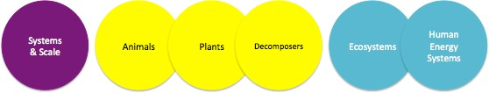

- Why do you recommend teaching Systems & Scale first?
A: For three reasons!

First, Systems & Scale is the simplest unit. It focuses on only one carbon-transforming process: combustion. This unit provides an introduction to key features and principles of the Carbon TIME program in the least complex context possible. In comparison, other units address multiple processes in inherently more complex systems (e.g., the Animals unit addresses digestion, biosynthesis, AND cellular respiration).

Second, the Systems & Scale unit provides scaffolding not present in the other units to help students who are just beginning to reason about matter and energy in systems. The unit includes a Soda Water Fizzing investigation (Lesson 3) that introduces the practice of tracing matter. Systems & Scale also includes a second investigation about Ethanol Burning (Lesson 4) that involves tracing both matter and energy. In other units, students are asked to trace both matter and energy from the beginning and in much more complex contexts. This is very challenging when students are unfamiliar with the tools and fundamental principles in the Carbon TIME units.

Third, the Systems & Scale unit introduces students to important practices and tools that they will use in more rigorous contexts in later units. The practices include data collection, pattern identification, data analysis, measurement, and tracing matter and energy. The tools include the Powers of Ten poster, molecule posters, investigation videos, data collection posters, molecular modeling kits, and chemical change animations.

I don’t see how Systems & Scale is related to Biology/Life Science. Do I still have to teach it?
A: Yes. Although it may not seem at first glance that the Systems & Scale unit is directly related to biology concepts, we have found through trial, error, and research that Systems & Scale provides a crucial foundation for successful learning in the other units. Although Systems & Scale may not appear to address foundational content for a traditional biology course, it is foundational for the other Carbon TIME units.

What is the most typical/common order to teach the units?
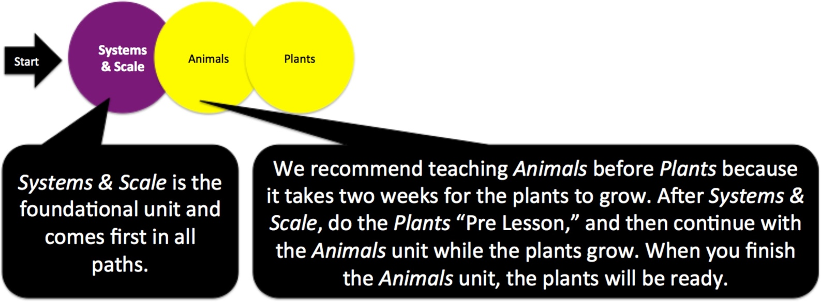
A: The most typical sequence is: Systems & Scale, Animals, Plants.

- Can I start with the Ecosystems or Human Energy Systems unit?
A: No. Although some ecology and energy-focused units may be appropriate to teach in isolation, the Carbon TIME Large Scale units depend on key knowledge developed in previous Carbon TIME units. Teaching either Ecosystems or Human Energy Systems without first teaching the Foundational unit and one Organism Scale unit will result in a less successful learning experience for students. Prerequisites for the Large-Scale units include 1) the Foundational unit, and 2) at least 1 Organism Scale unit (preferably Plants because of the focus on photosynthesis and cellular respiration, both of which play big roles in the Large Scale units).
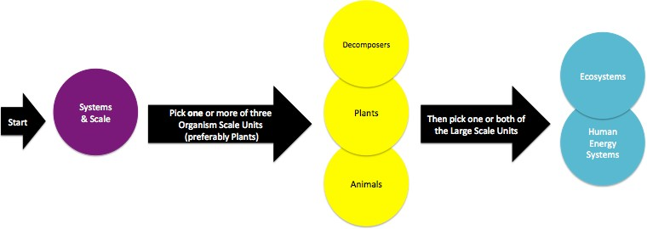

I teach 6th grade. We teach ecology. Our district doesn’t address physical science until 7th grade. Should I still teach Systems & Scale?
A: Yes. Although it may not seem at first glance that the content of the Systems & Scale unit is directly related to ecology, we have found through trial, error, and research that the knowledge and practices in the Systems & Scale unit provide a crucial foundation for the other units. Although Systems & Scale may not appear to address foundational content for a traditional ecology course, it is foundational for the other Carbon TIME units, especially Ecosystems.
- My students studied Systems & Scale last year. Should I skip it this year?
A: Depends. We recommend using the Systems & Scale unit pretest to assess your students’ understanding of the basic concepts required for the other units (e.g., precision with matter and energy tracing, scale, and conservation of matter and energy). Depending on how your students do on the pre- assessment, you may decide to revisit part or all of the Systems & Scale unit before moving on. Multiple experiences with basic Carbon TIME concepts can facilitate student learning. We highly recommend using evidence of student learning from the pre-test to make this decision.

I teach [a certain grade/course]. What is your recommended path for my particular course?
A: We recommend following these pathways:

Recommended Path for High School Biology
Recommended Path for Middle School Life Science

Systems%% &%Scale%
Animals%
Plants% Ecosystems%
Start%
If%?me,%add%
Decomposers)
Systems%% &%Scale%
Animals%
Plants%
Ecosystems%
Start%
If%?me,%add%
Decomposers)

Recommended Path for High School Environmental Science

Recommended Path for Middle School Physical Science

Systems%% &%Scale%
Plants%
Start%
Human% Energy% Systems%
If%?me,%add%
Ecosystems)
Systems%% &%Scale%
Plants%
Start%
Human% Energy% Systems%

I am a middle school teacher. Which part of the units should I omit if I want to reduce time and not delve too deeply into what is more typically taught in high school?
A: Depends on the unit. Although if time allows, you might consider teaching the whole unit at middle school-- redundancy across grades can help build on more complex concepts.
  - Systems & Scale: This entire unit is appropriate for Middle School.
  - Animals: Omit the biosynthesis application activities (Activities 4.1 and 4.2).
  - Plants: There are multiple “pathway” options available in the Plants unit. Pathway a, generally speaking, is more appropriate for more advanced high school students. So, we recommend choosing pathways b or c for middle school students when given a choice.
  - Decomposers: Omit the biosynthesis application activities (Activities 3.2 and 3.3).
  - Ecosystems: This entire unit is appropriate for Middle School.
  - Human Energy Systems: This entire unit is appropriate for Middle School.

I don’t have time to teach the entire [fill in the blank] unit. Which part should I prioritize, and which parts may I omit?
A: Depends on the unit. We recommend making your decision based on what you have already taught and what you will be teaching in the future.
  - Systems & Scale: Prioritize ethanol burning inquiry and application (Lesson 4). Omit the Lesson 3 (Investigating and Explaining Soda Water Fizzing). Lesson 4 is a more complete application sequence for ethanol burning that accomplishes similar goals. You may also omit Activity 5.4, which offers opportunities for application of the ideas from the unit in new contexts.
  - Animals: Prioritize mealworms moving inquiry and application (Lessons 3 and 4). Omit the biosynthesis activities in Lesson 4. You may also omit Activity 5.1 which offers opportunities for application of the ideas from the unit in new contexts.
  - Plants: Prioritize photosynthesis and cellular respiration inquiry and application (Lessons 2 and 3). Omit Lesson 4 (Explaining How Plants Grow). You may also omit Activity 5.1, which offers opportunities for application in new contexts.
  - Decomposers: Omit Activities 3.2 and 3.3 (Digestion and Biosynthesis), especially if your students have already studied these processes in either the Animals or Plants units. You may also omit Activities 4.1 and 4.2, which offer opportunities for application of the ideas from the unit in new contexts.
  - Ecosystems: Omit Activity 4.3 (Ecosystem Disturbances) and Activity 5.1 (Ecosystem Services and Carbon in Ecosystems). These provide additional contexts for Application of the main ideas from the unit, but are not crucial.
  - Human Energy Systems: Prioritize Lessons 2-6. Omit Lessons 1, 2, and 7.

I am teaching multiple units. Some content is repetitive. What should I prioritize/omit?
A: We recommend using this table to inform your decision.

Carbon Transforming Processes (CTPs) |  | Carbon TIME unit
 |  | Systems & Scale | Animals | Plants | Decomposers | Ecosystems | Human Energy  Systems
 | Combustion
 | Photosynthesis
 | Biosynthesis
 | Digestion
 | Cellular Respiration

As you can see, different Carbon Transforming Processes (CTPs) are addressed in different units. Note that the only units that address combustion and photosynthesis are Systems & Scale and Plants. This means you should prioritize these unique foci during these units. However, you’ll also notice that some CTPs are repeated in different units. For example, you may find that by the time you teach the Decomposers unit, your students may be familiar with digestion, biosynthesis, and cellular respiration. However, if your students have engaged only in the Systems & Scale and Plants units before they take the Decomposers pretest, they will probably do poorly on questions related to digestion (because this is not addressed in the Plants unit). We recommend making decisions about what to prioritize and what to omit in each unit based on both: 1) your students’ responses to the unit pretest, and 2) what units you have already taught, and what units you plan to teach in the future.

Also, note that in this table the cells in the two Large Scale units (Ecosystems & Human Energy Systems) are light orange (i.e., they include all of the CTPs). The different color indicates that there is no focus (e.g., an inquiry or application sequence) dedicated to the teaching and learning of these CTPs. Instead, students are expected to apply their previously developed knowledge of all five CTPs in these two units as they study matter and energy cycles and flows through large scale, global carbon pools.
- Can I teach Carbon TIME to elementary school students?
A: No. The cognitive demands of the units are not appropriate for elementary school students.

How does Carbon TIME build deep and connected knowledge and practice around big ideas?
A: Our research indicates that as students progress through the Carbon TIME program, their achievement increases on each subsequent unit pre and posttest. For example, students do better on the Decomposers pretest if they have already experienced two units compared with just one. Evidence suggests that students’ knowledge and practice builds over time through engaging in the learning experiences of multiple Carbon TIME units.

But what is building? The knowledge that builds over time is related to big ideas and principles, not just to context-specific knowledge. In each of the units, students study how matter and energy cycle and flow through systems. In contrast, context-specific information is different in each unit depending on its topic. For example, Decomposers is the only unit in which students learn that mold digests its food using hyphae; Plants is the only unit in which students learn the specific inputs and outputs for photosynthesis; and Human Energy Systems is the only unit in which students learn why levels of atmospheric carbon are increasing.

But in all of these contexts, the same principles apply: Matter and energy cannot be created or destroyed! Atoms are forever! Matter cycles! Energy flows! In each specific context (e.g., mold, photosynthesis, atmospheric carbon), students trace matter and energy through relevant systems and processes.

