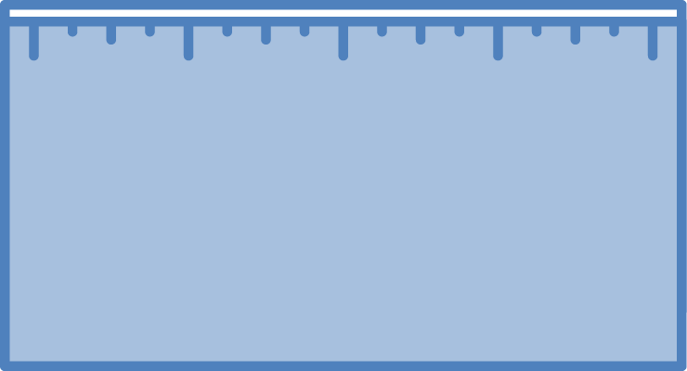
Answer each of the questions (numbered 1-4) below to explain how matter and energy move and change in a system. Note that matter movement is addressed at both the beginning (1) and end (4) of your explanation.
Evidence We
Can Observe
BTB can indicate CO₂ in the air.
Organic materials are made up of molecules containing carbon atoms:
- fuels
- foods
- living and dead plants and animals
- decomposers
Evidence We
Can Observe
We can observe indicators of different forms of energy before and after chemical changes:
- light energy
- chemical energy stored in organic materials
- motion energy
- heat energy
Rules to Follow
Energy lasts forever in combustion and living systems.
Energy can be transformed, but not created or destroyed.
C-C and C-H bonds have more stored chemical energy than C-O and H-O bonds.
Scale: The energy change question can be answered at the atomic-molecular, cellular, or macroscopic scales.
Rules to Follow
Atoms last forever in combustion and living systems.
Atoms can be rearranged to make new molecules, but not created or destroyed.
Carbon atoms are bound to other atoms in molecules.
Scale: The matter change question is always answered at the atomic-molecular scale.
Rules to Follow
All materials (solids, liquids, and gases) are made of atoms that are bonded together in molecules.
Scale: The matter movement question can be answered at the atomic-molecular, cellular, or macroscopic scale.
Question
Where are molecules moving?
How do molecules move to the location of the chemical change?
How do molecules move away from the location of the chemical change?
Evidence We
Can Observe
Moving solids, liquids, and gases are made of moving molecules.
A change in mass shows that molecules are moving.
Question
How are atoms in molecules being rearranged into
different molecules?
What molecules are carbon atoms in before and after the chemical change?
What other molecules
are involved?
Question
What is happening
to energy?
What forms of energy are involved?
What energy transformations take place during the chemical change?

Three Questions Explanation Checklist
Scientists explain many processes in nature by connecting the things we can see with things we can’t see, such as chemical changes at the atomic-molecular scale. You can use the Three Questions as a guide to explaining these processes. Your explanation should include steps for each of the four numbered questions, and the checklist below will help you make sure you include important information. Remember that a good explanation also answers the question; return to your prompt to be sure you have answered yours.
Setting the stage
- Did you name the system (what fuel, plant, animal, or decomposer) where the process is happening?
- Did you name the carbon transforming process?
1. Matter movement: How do molecules move to the location of the chemical change?
- Did you “zoom in” to a location (a cell or part of a flame) where the change takes place?
- Did you identify the molecules that move to that location?
- Did you describe where those molecules came from?
- Did you say how they got to the location?
2. Matter change: How are atoms in molecules being rearranged into different molecules?
- Did you identify the reactants—the molecules that go into the chemical change?
- Did you identify the products—the new molecules that are created when the atoms from the reactants are rearranged?
- Did you follow the rule that “atoms last forever:” Are all the atoms that were in the reactant molecules in the product molecules?
3. Energy change: What is happening to energy?
- Did you identify the form(s) of energy before the chemical change?
- Did you identify the form(s) of energy after the chemical change?
- Did you follow the rule that “energy lasts forever:” Is all the energy that was there before the change still accounted for after the change?
4. Matter movement: How do molecules move away from the location of the chemical change?
- Did you identify the molecules that don’t move away and the molecules that do move away after the chemical change?
- Did you explain what happens to the molecules that move away—how they go to other parts of the system or leave the system?
Other Elements to Consider
- Did you use scientific vocabulary correctly?
- Did you organize your explanation logically to tell a story that flows?

