When you read, think about…  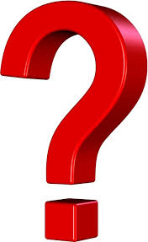 Questions  - What words or sentences were hard to understand?  - What questions do you have about them?  Connections  - How does this reading connect with what you have been learning in class?  - How does this reading connect with things that we see in the world around us?  - How does this reading connect with other things that you have read or heard?  Questions  - What new questions do you have after reading this? | When you read, think about…  Questions  - What words or sentences were hard to understand?  - What questions do you have about them?  Connections  - How does this reading connect with what you have been learning in class?  - How does this reading connect with things that we see in the world around us?  - How does this reading connect with other things that you have read or heard?  Questions  - What new questions do you have after reading this?
When you read, think about…  Questions  - What words or sentences were hard to understand?  - What questions do you have about them?  Connections  - How does this reading connect with what you have been learning in class?  - How does this reading connect with things that we see in the world around us?  - How does this reading connect with other things that you have read or heard?  Questions  - What new questions do you have after reading this? | When you read, think about…  Questions  - What words or sentences were hard to understand?  - What questions do you have about them?  Connections  - How does this reading connect with what you have been learning in class?  - How does this reading connect with things that we see in the world around us?  - How does this reading connect with other things that you have read or heard?  Questions  - What new questions do you have after reading this?

When you read, think about…
Questions
- What words or sentences were hard to understand?

- What questions do you have about them?

Connections
- How does this reading connect with what you have been learning in class?

- How does this reading connect with things that we see in the world around us?

- How does this reading connect with other things that you have read or heard?

Questions
- What new questions do you have after reading this?

