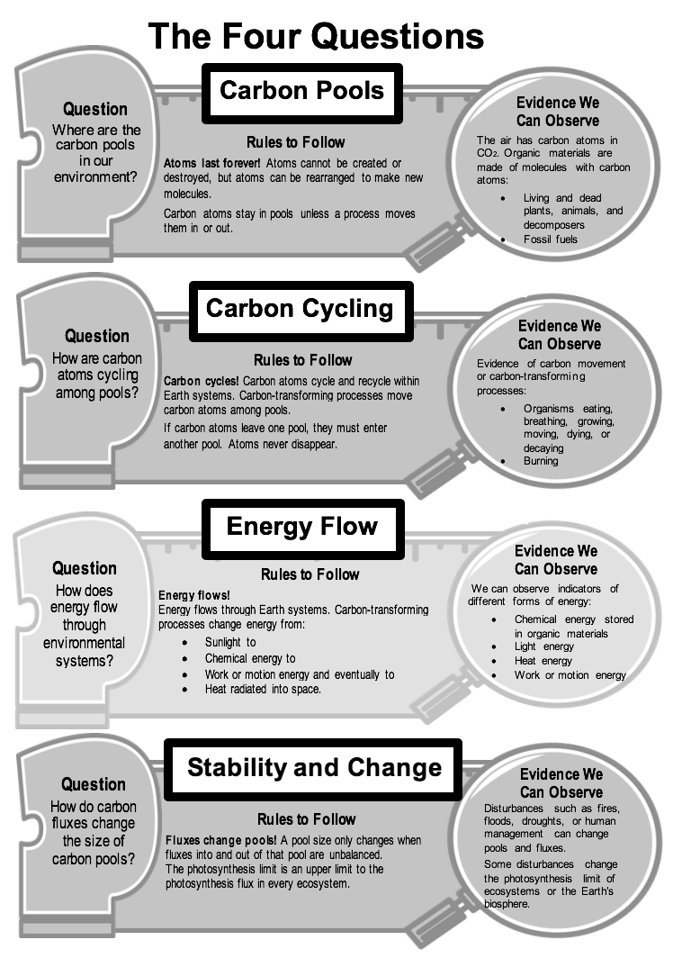

Four Questions Explanation Checklist
Scientists explain many processes in nature by connecting the things we can observe and measure (such as CO₂ concentrations in the atmosphere) with things that are more difficult to observe and measure (such as carbon pools and fluxes). You can use the Large-Scale Four Questions as a guide for using pools and fluxes to explain Earth systems and processes. The checklist below will help you make sure you include important information.

Setting the stage
- Did you name and describe the observations or patterns in data that you are explaining?
- Did you explain how the system is changing (or how you predict it will change)?

1. Carbon Pools: Where are the carbon pools in our environment?
- Did you name and describe all the pools that are involved in the process?
- Did you say what kinds of carbon molecules are in the pool (CO₂ or organic carbon)?

2. Carbon Cycling: How are carbon atoms cycling among pools?
- Did you name all the fluxes that move carbon atoms from one pool to another?
- Did you explain the chemical changes that go with those carbon fluxes?

3. Energy Flow: How does energy flow through environmental systems?
- Did you identify the carbon pools with stored chemical energy?
- Did you explain where the chemical energy in those pools comes from?
- Did you explain how energy is transformed in carbon fluxes?

4. Stability and Change: How do carbon fluxes change the size of carbon pools?
- Did you explain whether the fluxes going into or out of each pool are balanced or unbalanced?
- Did you explain or predict how unbalanced fluxes will change the size of pools?

Other Elements to Consider
- Did you use scientific vocabulary correctly?
- Did you organize your explanation logically to tell a story that flows?

