**The Four Questions**

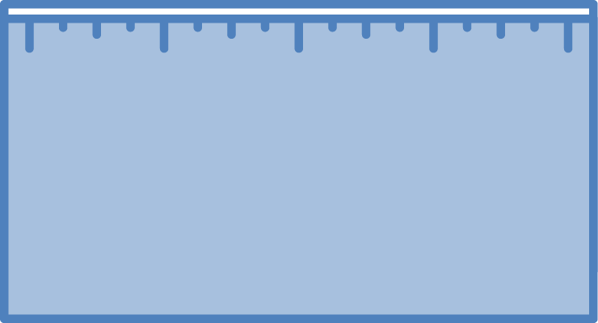

**Question**

Where are the carbon pools in our environment?

**Rules to Follow**

**Atoms last forever!** Atoms cannot be created or destroyed, but atoms can be rearranged to make new molecules.

Carbon atoms stay in pools unless a process moves them in or out.

**Evidence We   
Can Observe**

The air has carbon atoms in CO2. Organic materials are made of molecules with carbon atoms:

* Living and dead plants, animals, and decomposers
* Fossil fuels

**Carbon Pools**



**Question**

How are carbon atoms cycling among pools?

**Rules to Follow**

**Carbon cycles!** Carbon atoms cycle and recycle within Earth systems. Carbon-transforming processes move carbon atoms among pools.

If carbon atoms leave one pool, they must enter   
another pool. Atoms never disappear.

**Evidence We   
Can Observe**

Evidence of carbon movement or carbon-transforming processes:

* Organisms eating, breathing, growing, moving, dying or decaying
* Burning

**Carbon Cycling**

**Energy Flow Flow**



**Question**

How does energy flow through environmental systems?

**Rules to Follow**

**Energy flows!**

Energy flows through Earth systems. Carbon-transforming processes change energy from:

* Sunlight to
* Chemical energy to
* Work or motion energy and eventually to
* Heat radiated into space.

**Evidence We   
Can Observe**

We can observe indicators of different forms of energy:

* Chemical energy stored in organic materials
* Light energy
* Heat energy
* Work or motion energy



**Stability and Change**

**Question**

How do carbon fluxes change the size of carbon pools?

**Rules to Follow**

**Fluxes change pools!** A pool size only changes when fluxes into and out of that pool are unbalanced.

The carrying capacity is an upper limit to the photosynthesis flux in every ecosystem

**Evidence We Can Observe**

Disturbances such as fires, floods, droughts, or human management can change pools and fluxes.

Some disturbances change the carrying capacity of ecosystems

or the Earth’s biosphere