6.4: Grading the Human Energy Systems Unit Posttest
This posttest is the same as the Human Energy Systems Unit Pretest (Activity 1.1). The file “1.1_Assessing_the_Human_Energy_Systems_Unit_Pretest” explains how the unit pretest can be used for formative assessment, providing insight into students’ reasoning using the Learning Progression Framework. This file explains how the posttest can be used for grading, holding students accountable for the ideas that they have studied in the Human Energy Systems Unit.

Level 4 responses are in bold blue italics below.
Red italics suggest ways to grade student responses by giving them points for correct or partially correct answers.

These are difficult questions, so even the most sophisticated reasoners will miss a few of them. You should decide how to translate the number of points that students earn into grades for report cards. Here are some ideas about levels of points that represent excellent, good, and adequate performance.
Total possible: 23 points | For higher demand high school courses | For middle school or lower demand high school courses
Excellent | 18 points (~80%) | 16 points (~70%)
Good | 16 points (~70%) | 14 points (~60%)
Acceptable | 14 points (~60%) | 12 points (~50%)

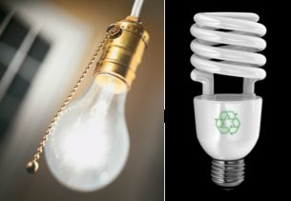
1. Fluorescent light bulbs use less energy than incandescent light bulbs. Do you think that using fluorescent light bulbs instead of incandescent light bulbs can reduce the amount of carbon dioxide going into our atmosphere? YES NO

Explain your answer. How can using fluorescent bulbs help reduce the amount of carbon dioxide going into our atmosphere, or why will they not help?
Level 4 responses will most likely connect the energy in the light bulb with the burning of fossil fuels in a power plant (the location of where the fossil fuels are burned is important). These responses may suggest that since fluorescent light bulbs use less energy, they require less burning of fossil fuels, which in turn sends less carbon dioxide into the atmosphere.
1 point for correct yes/no answer. 1 point for correctly connecting energy with fossil fuels. 2 points total.

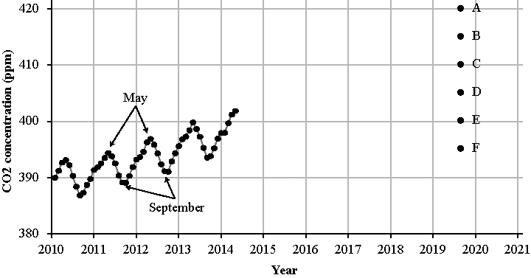
This figure shows the concentration (ppm) of CO₂ in the atmosphere from 2010 to 2014. These data were collected at the Mauna Loa Observatory on top of a tall mountain on the island of Hawaii. Each data point represents the average CO₂ concentration in the atmosphere at the top of the mountain in a particular month.

2. a) The data stop in May, 2014. Please predict how likely the following values are for the CO₂ concentration five years later, in May, 2019:
A) 420 ppm likely / possible but not likely / not possible
B) 415 ppm likely / possible but not likely / not possible
C) 410 ppm likely / possible but not likely / not possible
D) 405 ppm likely / possible but not likely / not possible
E) 400 ppm likely / possible but not likely / not possible
F) 395 ppm likely / possible but not likely / not possible

b) Explain your reasoning. Why are the values you chose for May, 2019, more likely than the others?
Level 4 responses will explain that B and C are predictable by explaining how they used evidence from previous years to make their prediction. The yearly data shows that each year prior to 2014, CO₂ levels peaked in May for that year. The long-term trend shows us that each May the CO₂ concentration increases slightly (between 2-5 ppm). Using both of these trends in the graph, it is likely that because the May 2014 CO₂ concentration is about 402, it is most likely that the CO₂ concentration a year later will be around 410 or 415 five years later.
1 point for each correct forced choice. 1 point for correctly explaining forced choice answers. 7 points total.

3. a) Every year the CO₂ concentration is a little higher than the year before. What causes this trend? Please rate the likelihood that the following activities cause the trend in CO₂ concentration over five years:

Measurement error (poor equipment or mistakes that the observers made): | The main cause | A minor cause | Not a cause
Variation in people’s use of fossil fuels (e.g., driving cars, heating homes) | The main cause | A minor cause | Not a cause
Variation in plant growth | The main cause | A minor cause | Not a cause
Variation in volcanic activity | The main cause | A minor cause | Not a cause
Variation in nuclear power plant use | The main cause | A minor cause | Not a cause
Global climate change | The main cause | A minor cause | Not a cause

b) Explain your reasoning. Why is the main cause you chose for the upward trend more important than the others?
Level 4 responses recognize that fossil fuels are the primary cause of the upward trend over time.
1 point for correctly answering each forced choice question. 1 point for correctly explaining that fossil fuels leads to an increase in carbon dioxide. 7 points total.

4. a) Do you think we could use the data in the above figure to tell us anything about how CO₂ concentrations are changing in your state from 2010 to 2015?

Choose one: YES NO

b) Why or why not?
Level 4 responses recognize that CO₂ spreads throughout the atmosphere.
1 point for correctly answering yes/no question. 1 point for correctly explaining that Mauna Loa is comparable to your state. 2 points total.

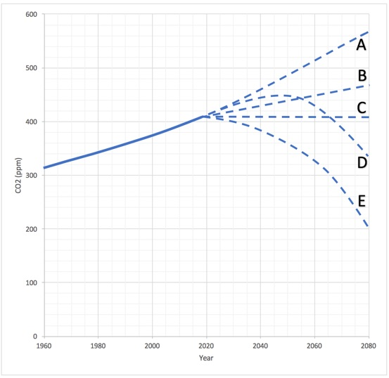
In the figure above, the first part of the line in the graph shows how carbon dioxide (CO₂) concentrations in the atmosphere changed between1960 and 2016.

5. a) If the world were suddenly able to cut its use of fossil fuels in half tomorrow and maintain that low level of use, what would be the effect on the concentration of atmospheric CO₂?

Choose the line that best predicts what you think would happen to CO₂ levels. CO₂ concentrations would:
A) continue to rise at about the same rate due to other factors
B) continue to rise, but more slowly
C) level off to a constant amount
D) continue to rise for a few years, then start to decline
E) decline to about half of what they are now
b) Explain your answer. How would reducing our use of fossil fuels affect global CO₂ concentrations?
Level 4 responses recognize that fossil fuels are the primary cause of the upward trend over time and that cutting the use of fossil fuels in half would change the trajectory of CO2 concentrations but levels would still rise since fossil fuels are still be produced and contributing to CO2 levels.
1 point for correct multiple choice. 1 point for correct explanation. 2 points total.
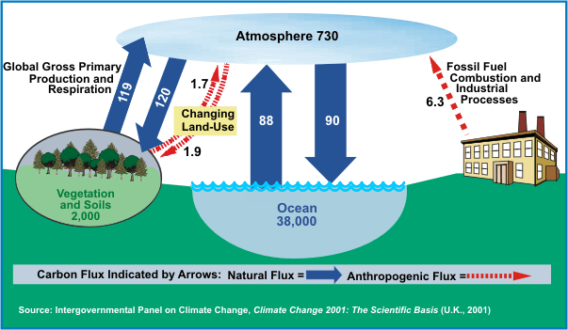
The diagram above is a picture of the global carbon cycle. It shows some of the different places, or pools, where carbon is found on the planet and how much carbon each pool contains (in gigatonnes, Gt). The arrows show how much carbon moves in and out of the different carbon pools in one year.

6. a) Using the diagram, reconsider the predictions you made in the previous question regarding what would happen to the concentration of CO₂ in the atmosphere were fossil fuel emissions to be suddenly cut in half.
Choose the line that best predicts what you think would happen to CO₂ levels given the information shown in the carbon cycle diagram above.

CO₂ concentrations would:
A) continue to rise at about the same rate due to other factors
B) continue to rise, but more slowly
C) level off to a constant amount
D) continue to rise for a few years, then start to decline
E) decline to about half of what they are now

b) Did you change your prediction after seeing the diagram? Yes No

c) Explain why you either did or did not change your prediction after seeing the diagram.
Level 4 responses recognize that the diagram shows similar input and outputs from natural fluxes and a large anthropogenic flux from fossil fuels contributing to atmospheric CO2 levels such that students recognize that fossil fuels are the primary cause of the upward trend over time and that cutting the use of fossil fuels in half would change the trajectory of CO2 concentrations. Level 4 responses also may add up the inputs and outputs and determine that more CO2 moves out of the atmosphere into different pools and thus CO2 may level off.
1 point for correct multiple choice. 1 point for answering yes/no. 1 point for explanation using the diagram correctly. 3 points total.

