Activity 1.1: Human Energy Systems Unit Pretest
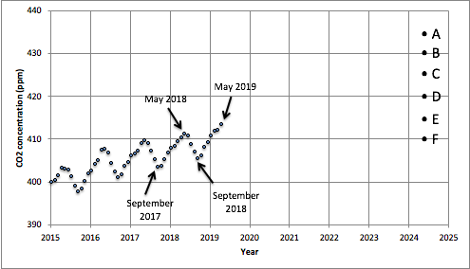
This figure shows the concentration (ppm) of CO₂ in the atmosphere from 2015 to 2019. These data were collected at the Mauna Loa Observatory on top of a tall mountain on the island of Hawaii. Each data point represents the average CO₂ concentration in the atmosphere at the top of the mountain in a particular month.
1. a) The data stop in May, 2019. Please predict how likely the following values are for the CO₂ concentration five years later, in May, 2024:
A) 435 ppm likely / possible but not likely / not possible
B) 430 ppm likely / possible but not likely / not possible
C) 425 ppm likely / possible but not likely / not possible
D) 420 ppm likely / possible but not likely / not possible
E) 415 ppm likely / possible but not likely / not possible
F) 410 ppm likely / possible but not likely / not possible
b) Explain your reasoning. Why are the values you chose for May, 2024, more likely than the others?

2. a) Every year the CO₂ concentration is a little higher than the year before. What causes this trend? Please rate the likelihood that the following activities cause the trend in CO₂ concentration over five years:
Measurement error (poor equipment or mistakes that the observers made): | The main cause | A minor cause | Not a cause
Variation in people’s use of fossil fuels (e.g., driving cars, heating homes) | The main cause | A minor cause | Not a cause
Variation in plant growth | The main cause | A minor cause | Not a cause
Variation in volcanic activity | The main cause | A minor cause | Not a cause
Variation in nuclear power plant use | The main cause | A minor cause | Not a cause
Global climate change | The main cause | A minor cause | Not a cause

b) Explain your reasoning. Why is the main cause you chose for the upward trend more important than the others?

3. a) Do you think we could use the data in the above figure to tell us anything about how CO₂ concentrations are changing in your state from 2015 to 2019?
Choose one: YES NO
b) Why or why not?

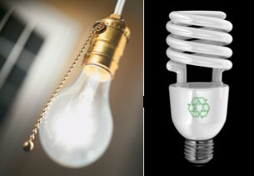
4. Fluorescent light bulbs use less electrical energy than incandescent light bulbs. Do you think that using fluorescent light bulbs instead of incandescent light bulbs can reduce the amount of carbon dioxide going into our atmosphere? YES NO

Explain your answer. How can using fluorescent bulbs help reduce the amount of carbon dioxide going into our atmosphere, or why will they not help?

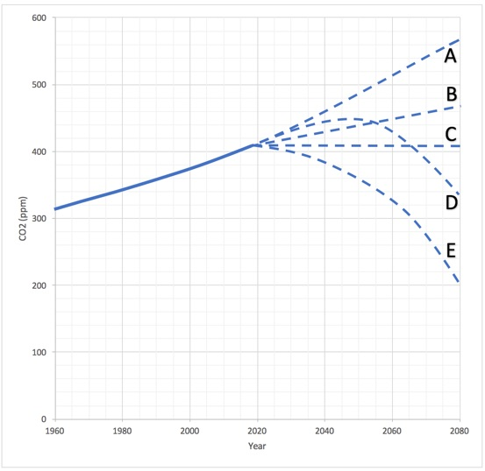
In the figure above, the first part of the line in the graph shows how carbon dioxide (CO₂) concentrations in the atmosphere changed between1960 and 2016.
5. a) If the world were suddenly able to cut its use of fossil fuels in half tomorrow and maintain that low level of use, what would be the effect on the concentration of atmospheric CO₂?
Choose the line that best predicts what you think would happen to CO₂ levels. CO₂ concentrations would:
A) continue to rise at about the same rate due to other factors
B) continue to rise, but more slowly
C) level off to a constant amount
D) continue to rise for a few years, then start to decline
E) decline to about half of what they are now

b) Explain your answer. How would reducing our use of fossil fuels affect global CO₂ concentrations?

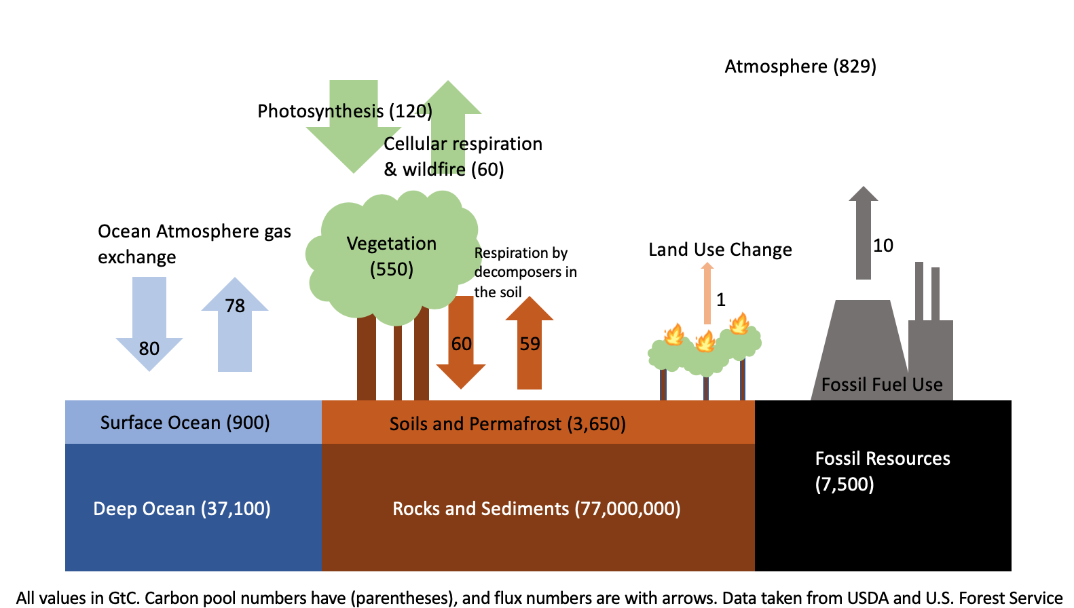
The diagram above is a picture of the global carbon cycle. It shows some of the different places, or pools, where carbon is found on the planet and how much carbon each pool contains (in gigatonnes, Gt). The arrows show how much carbon moves in and out of the different carbon pools in one year.
6. a) Using the diagram, reconsider the predictions you made in the previous question regarding what would happen to the concentration of CO₂ in the atmosphere were fossil fuel emissions to be suddenly cut in half.
Choose the line that best predicts what you think would happen to CO₂ levels given the information shown in the carbon cycle diagram above.
CO₂ concentrations would:
A) continue to rise at about the same rate due to other factors
B) continue to rise, but more slowly
C) level off to a constant amount
D) continue to rise for a few years, then start to decline
E) decline to about half of what they are now
b) Did you change your prediction after seeing the diagram?
Yes No
c) Explain why you either did or did not change your prediction after seeing the diagram.

