1.1: Ecosystems Unit Pretest
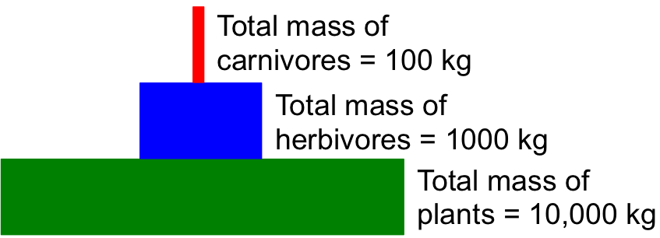
1. This graph shows a pattern that biologists have observed in most ecosystems on Earth. The total mass of plants is much more than the total mass of herbivores, and the total mass of herbivores is much more than the total mass of carnivores.
Why do you think that this is the case?

2. Here is a simple food chain with one plant, one animal, and some decomposers:
dies and is decomposed by

Grass | is eaten by | Rabbit |  |  | Decomposing bacteria

Circle true or false to the following questions:

True | False | The molecules in the rabbit came from the grass without changing.
True | False | The atoms in the rabbit came from the grass without changing.
True | False | The energy in the rabbit came from the grass without changing.
True | False | The bacteria recycle molecules from the dead rabbit back to the grass.
True | False | The bacteria recycle atoms from the dead rabbit back to the grass
True | False | The bacteria recycle energy from the dead rabbit back to the grass

Explain your answers: How do molecules move through the ecosystem that this food chain is part of?

Explain your answers: How do atoms move through the ecosystem that this food chain is part of?

Explain your answers: How does energy move through the ecosystem that this food chain is part of?

3. In a forest ecosystem, how would you expect the amount of carbon dioxide in the air to change in the winter?
The amount of carbon dioxide in the forest air (choose one):
a. Would increase
b. Would decrease
c. Would stay about the same
Explain your answer. What would cause the amount of CO2 in the forest air to change during the winter?

4. In a forest ecosystem, how would you expect the amount of carbon dioxide in the air to change in the summer.
The amount of carbon dioxide in the forest air (choose one):
a. Would increase
b. Would decrease
c. Would stay about the same
Explain your answer. What would cause the amount of CO₂ in the forest air to change during the summer?

5. Think about what might happen to carbon atoms and to energy in a forest. Decide whether each of the following pathways is possible or not:
Carbon atoms could leave the forest after they have been used by plants or animals. | Possible | Impossible
After carbon atoms have been used by plants or animals they could be recycled and used again by plants or animals. | Possible | Impossible
Energy could leave the forest after it has been used by plants or animals. | Possible | Impossible
After energy has been used by plants or animals it could be recycled and used again by plants or animals. | Possible | Impossible

Explain your thinking. How are the possible pathways for carbon atoms and for energy alike and different?

6. A remote island in Lake Superior is uninhabited by humans. The primary mammal populations are white-tailed deer and wolves. The island is left undisturbed for many years. Circle the best choice to complete the statement about what will happen to the average populations of the animals over time.
On average, the populations of deer and wolves will fluctuate, but:
a. there will be more deer than wolves.
b. there will more wolves than deer
c. the populations of each would be about equal.
d. sometimes there will be more deer and sometimes there will be more wolves.
e. None of the above.
Please explain your answer to what happens to the populations of deer and wolves.

