5.4: Grading Ecosystems Unit Posttest

This posttest is the same as the Ecosystems Unit Pretest (Activity 1.1). The file “1.1_Assessing_the_Ecosystems _Unit_Pretest” explains how the unit pretest can be used for formative assessment, providing insight into students’ reasoning using the Learning Progression Framework. This file explains how the posttest can be used for grading, holding students accountable for the ideas that they have studied in the Ecosystems Unit.
Correct responses are in bold blue italics below. Red italics suggest ways to grade student responses by giving them points for correct or partially correct answers.
These are difficult questions, so even the most sophisticated reasoners will miss a few of them. You should decide how to translate the number of points that students earn into grades for report cards. Here are some ideas about levels of points that represent excellent, good, and adequate performance.
Total possible: 22 points | For higher demand high school courses | For middle school or lower demand high school courses
Excellent | 18 points (~80%) | 16 points (~70%)
Good | 16 points (~70%) | 13 points (~60%)
Acceptable | 13 points (~60%) | 11 points (~50%)

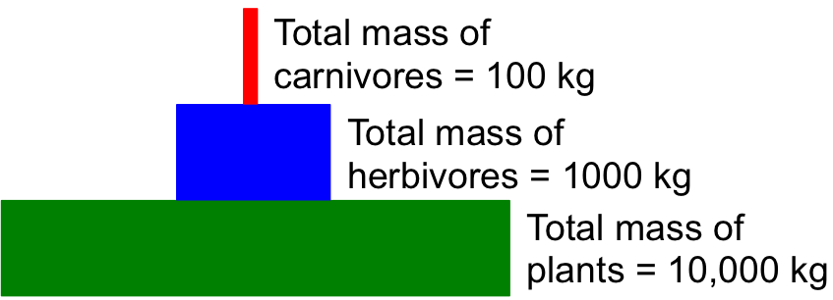
- This graph shows a pattern that biologists have observed in most ecosystems on Earth. The total mass of plants is much more than the total mass of herbivores, and the total mass of herbivores is much more than the total mass of carnivores.

Why do you think that this is the case?

Level 4 responses may indicate that mass is lost through cellular respiration with each level leaving less mass to be consumed by the next.
1 point for correctly explaining that mass is lost through cellular respiration.
- Here is a simple food chain with one plant, one animal, and some decomposers:
dies and is decomposed by
is eaten by
Grass |  | Rabbit |  |  | Decomposing bacteria

Circle true or false to the following questions:

True | False | The molecules in the rabbit came from the grass without changing.
True | False | The atoms in the rabbit came from the grass without changing.
True | False | The energy in the rabbit came from the grass without changing.
True | False | The bacteria recycle molecules from the dead rabbit back to the grass.
True | False | The bacteria recycle atoms from the dead rabbit back to the grass
True | False | The bacteria recycle energy from the dead rabbit back to the grass
1 point for each correct answer. 6 points total.

How do molecules move through the ecosystem that this food chain is part of?

Level 4 responses may suggest that plants, animals, and decomposers all take in molecules from their environment or other organisms and rearrange their atoms into different molecules; the atoms do not change.
1 point for correctly suggesting how all organisms rearrange the atoms of molecules that they take in into different molecules.

How do atoms move through the ecosystem that this food chain is part of?

Level 4 responses might suggest that atoms cycle in the ecosystem and are rearranged into new molecules during photosynthesis, digestion, decomposition, and cellular respiration (most of which happens in the process of organisms eating other organisms).
1 point for correctly explaining that atoms cycle and are rearranged to form different molecules.

How does energy move through the ecosystem that this food chain is part of?

Level 4 responses may suggest that plants take light energy from the sun and transform it to chemical energy in plant molecules, which goes through food chains and into soil carbon. During cellular respiration in plants, animals, and decomposers, the chemical energy in their cells is transformed to heat and motion energy. Once energy leaves the food chain as heat it cannot be reused again by the plants or animals.
1 point for correctly explaining how energy flows through an ecosystem

- In a forest ecosystem, how would you expect the amount of carbon dioxide in the air to change in the winter. The amount of carbon dioxide in the forest air would:
- increase
- decrease
- stay the same
What would cause the amount of CO₂ in the forest air to change during the winter?

Level 4 responses may suggest that during the winter the rate of photosynthesis decreases, and cellular respiration either stays the same or decreases slightly. Since there are fewer carbon atoms entering plants compared to in the summer (and since atoms last forever), the overall amount of carbon dioxide in the atmosphere increases.
1 point for correctly answering forced choice.
1 point for correctly explaining how the photosynthesis flux decreases in winter.
2 points total.

- In a forest ecosystem, how would you expect the amount of carbon dioxide in the air to change in the summer? The amount of carbon dioxide in the forest air would:
- increase
- decrease
- stay the same
What would cause the amount of CO₂ in the forest air to change during the summer?
Level 4 responses may suggest that during the summer, the rate of photosynthesis increases more than the rate of cellular respiration. Since more carbon atoms are entering plants, the overall amount of carbon dioxide in the atmosphere decreases.
1 point for correctly answering forced choice.
1 point for correctly explaining how the photosynthesis flux increases in summer.
2 points total.

- Think about what might happen to carbon atoms and to energy in a forest. Decide whether each of the following pathways is possible or not:

Carbon atoms could leave the forest after they have been used by plants or animals. | Possible | Impossible
After carbon atoms have been used by plants or animals, they could be recycled and used again by plants or animals. | Possible | Impossible
Energy could leave the forest after it has been used by plants or animals. | Possible | Impossible
After energy has been used by plants or animals, it could be recycled and used again by plants or animals. | Possible | Impossible
Explain your thinking. How are the possible pathways for carbon atoms and for energy alike and different?

Level 4 responses might suggest that carbon atoms last forever, so they could leave the forest are be recycled. Energy also lasts forever, but plants cannot reuse the heat energy that leaves the ecosystem, so energy cannot re-enter the food chain.
1 point for each correct choice. 1 point for correctly identifying how carbon leaves the forest. 5 points total.

- A remote island in Lake Superior is uninhabited by humans. The primary mammal populations are white-tailed deer and wolves. The island is left undisturbed for many years. Circle the best choice to complete the statement about what will happen to the average populations of the animals over time. On average, the populations of deer and wolves will fluctuate, but:
- there will be more deer than wolves.
- there will more wolves than deer.
- the populations of each would be about equal.
- sometimes there will be more deer and sometimes there will be more wolves.
- None of the above.

Please explain your answer to what happens to the populations of deer and wolves.

Level 4 responses may indicate that there will be more deer than wolves because as organic materials are eaten in a food chain, most of the food is used for cellular respiration (to release energy for the organism). One wolf will always need several deer (lots of organic carbon and chemical energy) in order to stay alive, and most of the organic carbon that makes up deer bodies will be respired by the wolf.
1 point for correct forced choice. 1 point for correctly explaining what happens to deer and wolf populations. 2 points total.

